Genetic Disorder

Submitted in Partial Fulfillment of the Second Continuous Assessment

Bachelor of Technology
in
Computer Science and Engineering (AI & ML)
4th Semester

Name:
University Roll No:
University Registration No:
Paper Name: Biology
Paper Code: BSC 401



Under the Guidance of Paper Faculty Name: Designation: Teacher

Department of CSE (AI & ML)

Future Institute of Technology
March 2023

Abstract
A genetic disorder is a disease caused in whole or in part by a change in the DNA sequence away from the normal sequence. Genetic disorders can be caused by a mutation in one gene, by mutations in multiple genes, by a combination of gene mutations and environmental factors, or by damage to chromosomes (changes in the number or structure of entire chromosomes, the structures that carry genes). Genes are the building blocks of heredity. They are passed from parent to child. They hold DNA, the instructions for making proteins. Proteins do most of the work in cells. They move molecules from one place to another, build structures, break down toxins, and do many other maintenance jobs. Sometimes there is a mutation, a change in a gene or genes. The mutation changes the gene's instructions for making a protein, so the protein does not work properly or is missing entirely. This can cause a medical condition called a genetic disorder.

1. Introduction:
Genetic disorders are conditions that occur due to changes to or mutations in DNA within the body’s cells.
Most cells in the body contain long strands of DNA that provide the cell with instructions. Each DNA strand is tightly coiled around a protein called a histone. This coiled structure is called a chromosome.
Chromosomes contain small sections of DNA called genes. These genes provide the body with a specific set of instructions. Each human cell normally contains 23 pairs of chromosomes, with one of each pair provided by each parent. Therefore, a person has two copies of every gene.
A change or fault in the DNA can cause a genetic condition. Since genes pass from parent to child, these disorders may be heritable. However, not everyone with a genetic condition in their family will experience symptoms of the disorder.
Genetic conditions can affect any gene or chromosome. This means that there is a wide range of genetic disorders, each causing various symptoms.

2. Problem Definition:

Genetic disorders occur when a mutation (a harmful change to a gene, also known as a pathogenic variant) affects your genes or when you have the wrong amount of genetic material. Genes are made of DNA (deoxyribonucleic acid), which contains instructions for cell functioning and the characteristics that make each unique.
Organisms receive half their genes from each biological parent and may inherit a gene mutation from one parent or both. Sometimes genes change due to issues within the DNA (mutations). This can raise your risk of having a genetic disorder. Some cause symptoms at birth, while others develop over time.
Some conditions, including certain rare and congenital diseases, have a grim prognosis. Children born with anencephaly typically survive only a few days. Other conditions, like an isolated cleft lip, do not affect lifespan. But you may need regular, specialized care to stay comfortable.

3. Discussion:

In certain situations e.g., due to environmental radiation, food intake, or internal genetic conditions, chromosomes may suffer damage or may change in numbers. The change in structure is called structural chromosomal abnormality (or aberration) and the change in number is called numerical chromosomal abnormality. When one chromosome of the pair is absent, the condition is called monosomy (2n-1) for that chromosome e.g., monosomy of chromosome 1. When a chromosome is present in three copies, this condition is called trisomy (2n+1) e.g., trisomy of chromosome X. It is important to notice that both monosomy and trisomy come under the broad category of aneuploidy. However, when the entire set of chromosomes is multiplied (e.g., 69: 23 ´ 3, 92: 23 ´ 4), the condition is called polyploidy. The artificial breeding of plants has resulted in several polyploid varieties that we commonly use in our food. For example, bread wheat has six sets of chromosomes, and cabbages or mustards are tetraploids. Likewise, bananas and apples are triploid (3 sets of chromosomes), and strawberries and sugar cane are octoploids (8 sets of chromosomes). Both structural and numerical changes can result in significant changes in phenotypic conditions in the form of diseases or syndromes.

Types of Genetic Disorders The types of genetic disorders that the patients of family physicians may have can be classified as follows:
1. Chromosome disorders: These disorders are caused by the loss, gain, or abnormal arrangement of one or more chromosomes. Their frequency in the population is about 0.2%.
2. Mendelian disorders: These disorders are single-gene defects caused by a mutant allele at a single genetic locus. The transmission pattern is divided further into autosomal dominant, autosomal recessive, X-linked dominant, and X-linked recessive. Their frequency is about 0.35%.
3. Multifactorial disorders: These disorders involve interactions between genes and environmental factors. The nature of these interactions is poorly understood. It includes cancers, diabetes, and most other diseases that develop during a patient’s life. The risks of transmission can be estimated empirically, and their estimated frequency in the population is about 5%.
4. Somatic genetic disorders: Mutations arise in somatic cells and are not inherited. They often give rise to malignancies. Although the mutation is not inherited, it often requires a genetic predisposition. 5. Mitochondrial disorders: These disorders arise from mutations in the genetic material in mitochondria. Mitochondrial DNA is transmitted through only the maternal line.

Chromosome disorders:

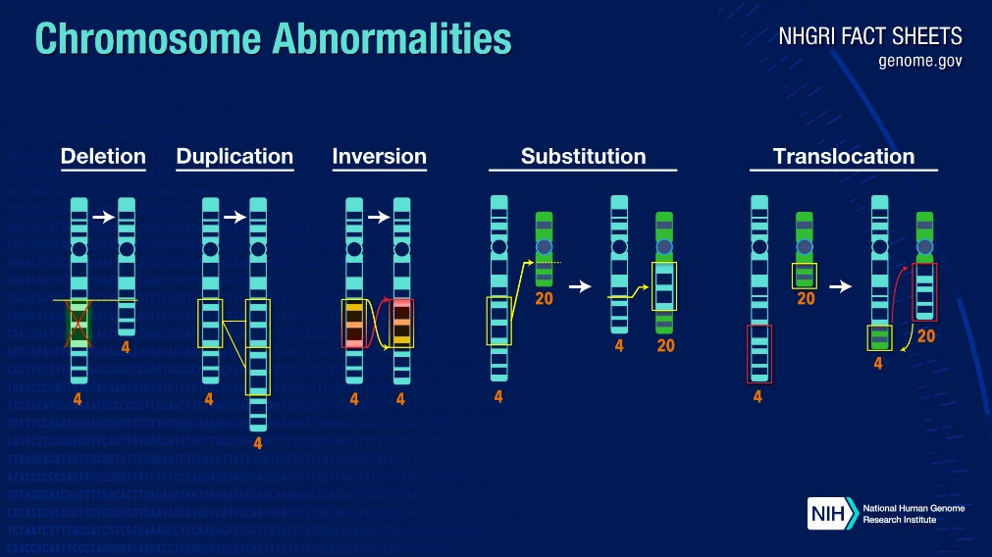
There are many types of chromosome abnormalities. However, they can be organized into two basic groups: numerical abnormalities and structural abnormalities.
- Numerical Abnormalities: When an individual is missing one of the chromosomes from a pair, the condition is called monosomy. When an individual has more than two chromosomes instead of a pair, the condition is called trisomy.
An example of a condition caused by numerical abnormalities is Down syndrome, which is marked by mental disability, learning difficulties, a characteristic facial appearance, and poor muscle tone (hypotonia) in infancy. An individual with Down syndrome has three copies of chromosome 21 rather than two; for that reason, the condition is also known as Trisomy 21. An example of monosomy, in which an individual lacks a chromosome, is Turner syndrome. In Turner syndrome, a female is born with only one sex chromosome, an X, and is usually shorter than average and unable to have children, among other difficulties.
- Structural Abnormalities: A chromosome's structure can be altered in several ways.
  - Deletions: A portion of the chromosome is missing or deleted.
  - Duplications: A portion of the chromosome is duplicated, resulting in extra genetic material.
  - Translocations: A portion of one chromosome is transferred to another chromosome. There are two main types of translocation. In a reciprocal translocation, segments from two different chromosomes have been exchanged. In a Robertsonian translocation, an entire chromosome has attached to another at the centromere.
  - Inversions: A portion of the chromosome has broken off, turned upside down, and reattached. As a result, the genetic material is inverted.
  - Rings: A portion of a chromosome has broken off and formed a circle or ring. This can happen with or without the loss of genetic material.
Most chromosome abnormalities occur as an accident in the egg or sperm. In these cases, the abnormality is present in every cell of the body. Some abnormalities, however, happen after conception; then some cells have the abnormality and some do not. Chromosome abnormalities can be inherited from a parent (such as a translocation) or be "de novo" (new to the individual). This is why, when a child is found to have an abnormality, chromosome studies are often performed on the parents.
Mendelian disorders:
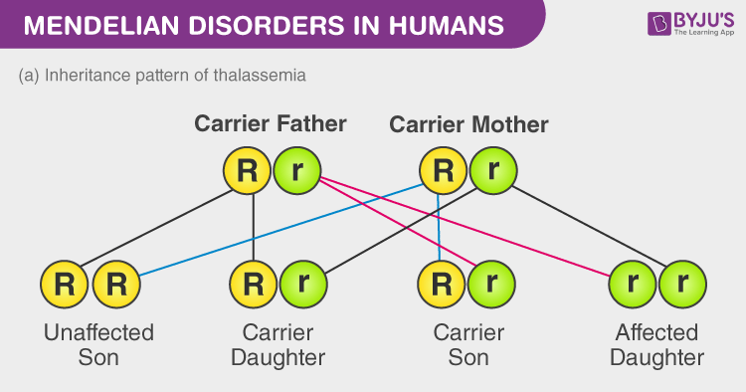
Mendelian disorders occur mainly by the alteration or mutation in a single gene. The inheritance of these disorders follows the principles of inheritance as described by Mendel. Pedigree analysis can be used to trace the pattern of inheritance of Mendelian disorders in a family. Mendelian disorders are of two types:
1) Sex-linked disorders
Sex-linked disorders are those which are caused by mutations in genes that are linked with sex chromosomes i.e. either with X-chromosome or Y-chromosome. Any defective gene that is inherited via the sex chromosomes is considered to be sex-linked. Sex-linked disorders are either dominant or recessive. In dominant inheritance, the defective gene received from one of the parents is dominant and is capable of causing disease in the offspring even in the presence of a normal allele in the homologous pair that is received from the other parent. On the contrary, for a sex-linked recessive disorder, the defective gene is recessive and is capable of expressing the disease in a person only if he or she inherits two recessive defective alleles, one from each parent. Examples of such disorders would include hemophilia, color blindness, etc.

2) Autosomal disorders
Autosomal disorders are a type of disorders that are linked with genes present on autosomes or chromosomes other than sex chromosomes. They are not sex-specific. These disorders can affect children of any sex. These disorders are either dominant or recessive. In dominant autosomal disorders, the defective allele is dominant and expresses the disease even in the presence of a recessive normal allele. In recessive autosomal disorder, the defective gene is recessive and can express the disease only in homozygous conditions, that is when an individual has the same pair of defective recessive alleles. Hence a person inherits a recessive autosomal disease only if he or she receives the defective allele from both parents during reproduction. Examples of such disorders would include thalassemia, sickle cell anemia, etc.

